Lab 7
Implementing a Point to Point VPN
Objective:
The purpose of this lab is for the student to understand basic features of and implement a Point to Point VPN. Students will utilize the ASA GUI to explore and configure a Cisco firewall.
Diagram:
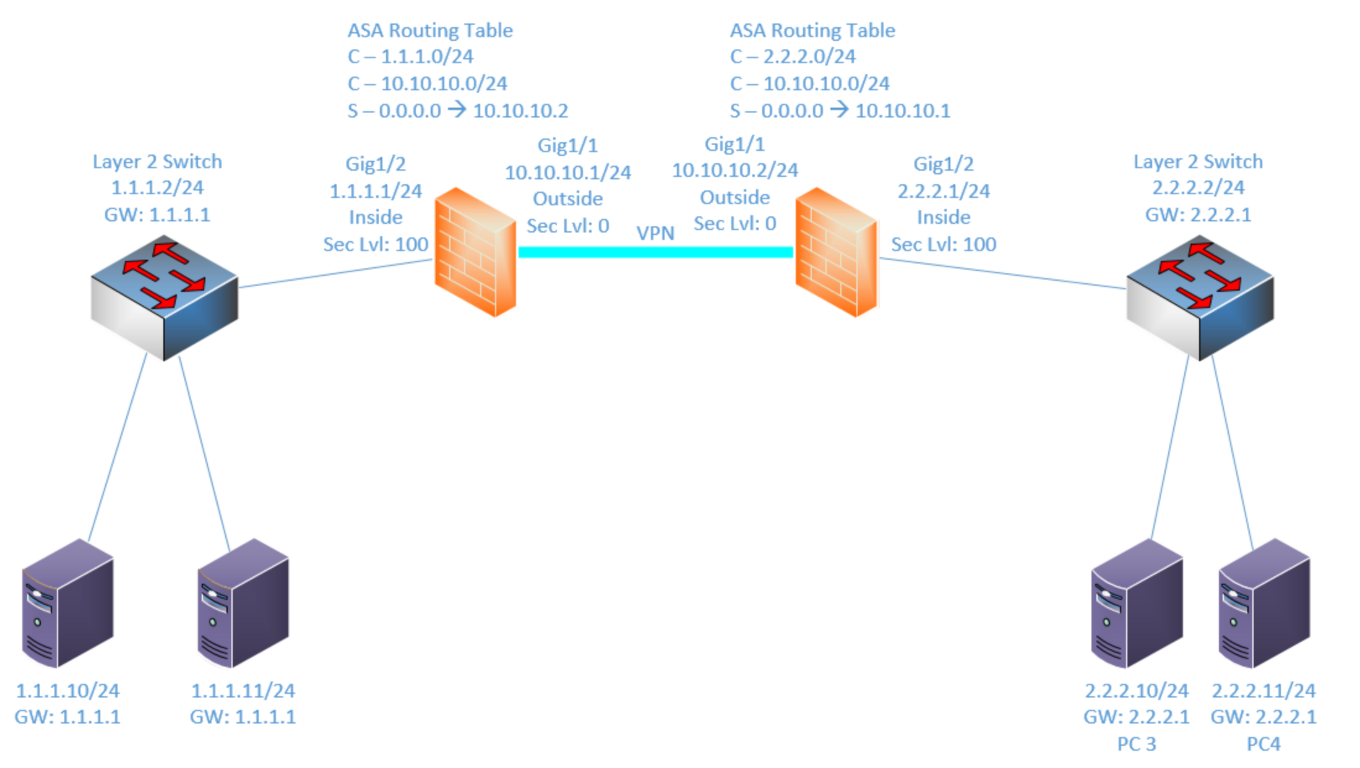

Components:
4 – PCs
2 – Cisco 3650 Layer 2 Switches
2 – Cisco 5516-X Firewalls
Procedure:
- Connect all PC’s together on the layer 2 switches and put their static IP addresses, subnet masks and gateways on them. Test connectivity by pinging each machine within the network.

- Use the diagram above to label the firewalls IP addresses and ports below
 | Name | IP | Interface | Security
Firewall 1 | Outside | 10.10.10.1/24 | GigabitEthernet1/1 | 0
 | Inside | 1.1.1.1/24 | GigabitEthernet1/2 | 100
Firewall 2 | Outside | 10.10.10.2/24 | GigabitEthernet1/1 | 0
 | Inside | 2.2.2.1/24 | GigabitEthernet1/2 | 100

- Configure the IP addresses on the Firewalls’ inside interfaces, set the name of the interface and the security level, and turn on the interfaces.

- Enable http access to the firewall and allow the 1.1.1.0/24 network to access it from the inside interface on firewall 1.

- Enable http access to the firewall and allow the 2.2.2.0/24 network to access it from the inside interface on firewall 2.

- Ping each firewall’s inside interfaces from a machine on the inside network and verify it is up and working.

- Connect to the firewall’s GUI through the web browser. (Unless the ASDM application is already on your desktop).

- Select the configuration tab and under device setup select interfaces

- Create the Interfaces for the outside network.

  - List the interface details below:
 | Interface | IP | Security | Name
Firewall 1 | GigabitEthernet1/1 | 10.10.10.1/24 | 0 | Outside
Firewall 2 | GigabitEthernet1/1 | 10.10.10.2/24 | 0 | Outside

- Add the default route and select the outside interface on both firewalls. Refer to the diagram if necessary.

- On Firewall1 Select Configuration, Firewall and click on NAT Rules. Remember ASA NATs use objects in the address fields. Create objects for any addresses you need for step 13.

- Click the arrow next to Add and choose Add Nat rule before “Network object” NAT rules.

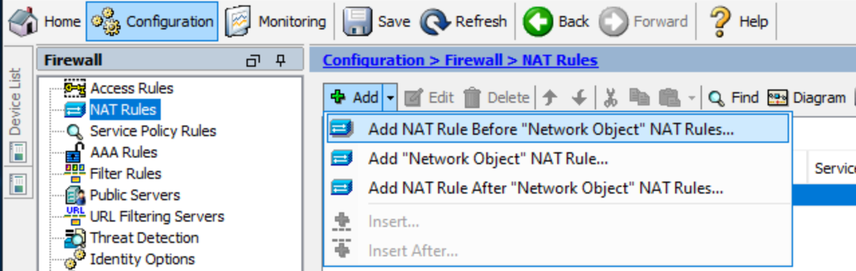

- Create a NAT rule with the following:

  - Source interface: inside
  - Source address: 1.1.1.0/24
  - Destination interface: outside
  - Destination address: 2.2.2.0/24
  - Translated source and destination original addresses.
  - It should look similar to this:
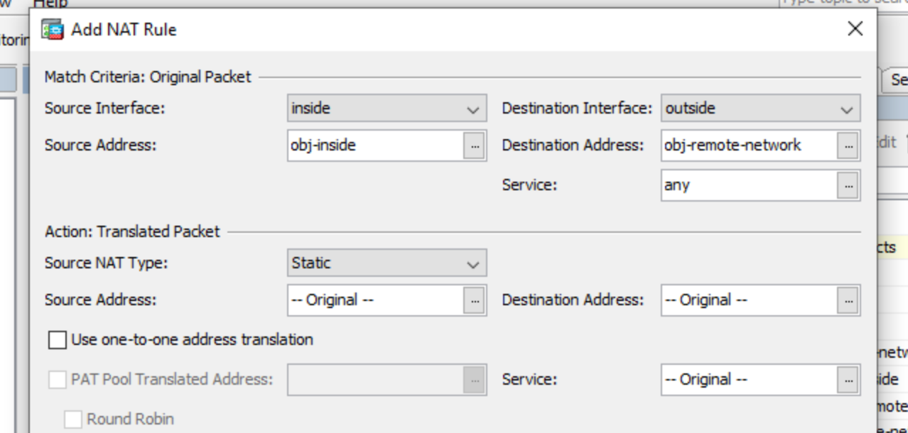

- Repeat steps 11-13 on Firewall 2, but make sure to reverse the source and destination addresses. The 2.2.2.0/24 network will be the source and 1.1.1.0/24 will be the destination.

- On Firewall 1 select Wizards VPN Wizards Site to Site VPN Wizard

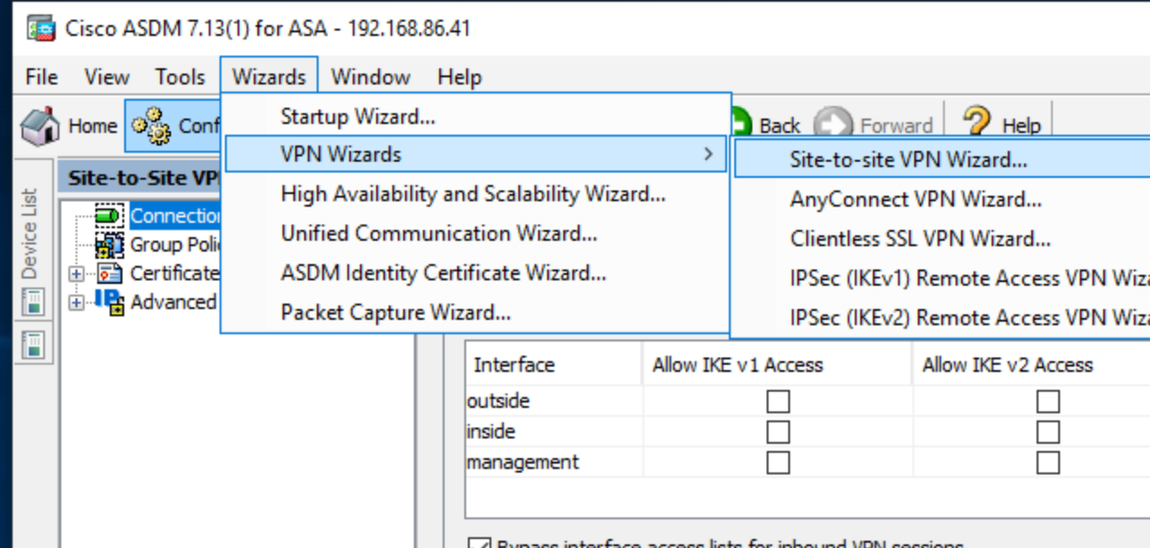

- Select Next and then enter the IP address of Firewall 2’s outside interface. Make sure the VPN access interface is outside. Click next when finished.
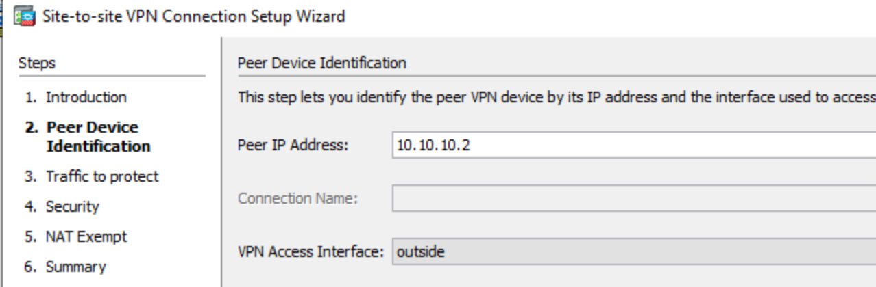

- Select 1.1.1.0/24 as the local network and 2.2.2.0/24 as the remote network. Click next when finished.

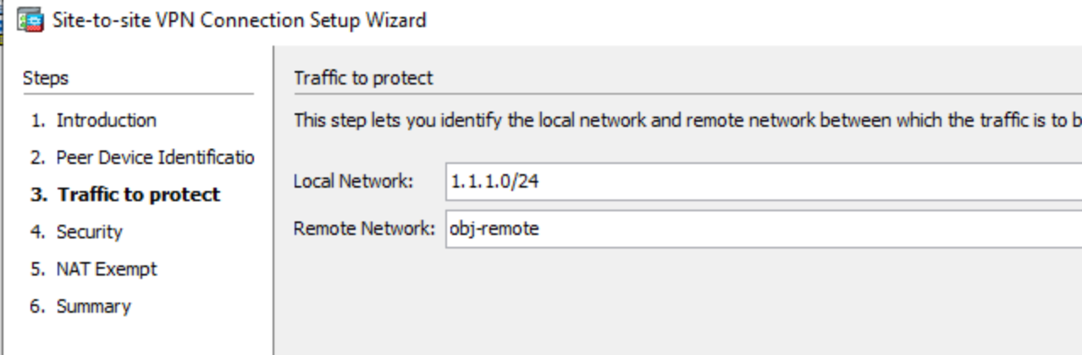

- Set a preshared key of netcom123
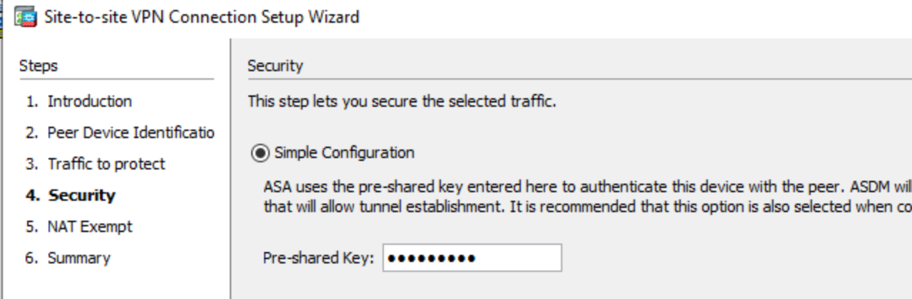

- Click Next. Ignore the NAT Exempt part since we already set up NAT in the previous step.

- Review the summary information. Notice all the additional information that is configured automatically for us. There are crypto policies and transform sets.

- Click Finish

- Can the 1.1.1.0/24 network ping the 2.2.2.0/24 Network? No, it can’t.
  - Why? The second Firewall hasn’t been configured for VPN yet and is receiving traffic it cannot interpret

- On Firewall 2 select Wizards VPN Wizards Site to Site VPN Wizard

- Follow steps 16-21 on Firewall 2. Remember the source and destinations are swapped since 2.2.2.0/24 is local and inside on this firewall.

- Can the 1.1.1.0/24 network ping the 2.2.2.0/24 Network? Yes
  - Why? Now both firewalls are configured for VPN

- Click on Monitoring and select the VPN Tab

- Can you tell if the VPN tunnel is established? Yes

- Does it show the peer IP addresses? Yes, it shows 10.10.10.1 for firewall 2 and 10.10.10.2 for firewall 1

- Does it show the local and remote networks? No

- Click on details.

  - Which type of IKE did your tunnel use? IKEv2

  - What is the port number and protocol the tunnel uses?
UDP/500 IPSEC
  - What encryption does the tunnel use? AES256 encryption

  - What hashing does the tunnel use? SHA1 hashing

  - Does it show the peer IP addresses? Yes, 10.10.10.2

  - Does it show the local and remote networks? Yes, the local network is 1.1.1.0/24 and the remote network is 2.2.2.0/24

- Screen shot the VPN details from both firewalls and paste them below:

FIREWALL 1
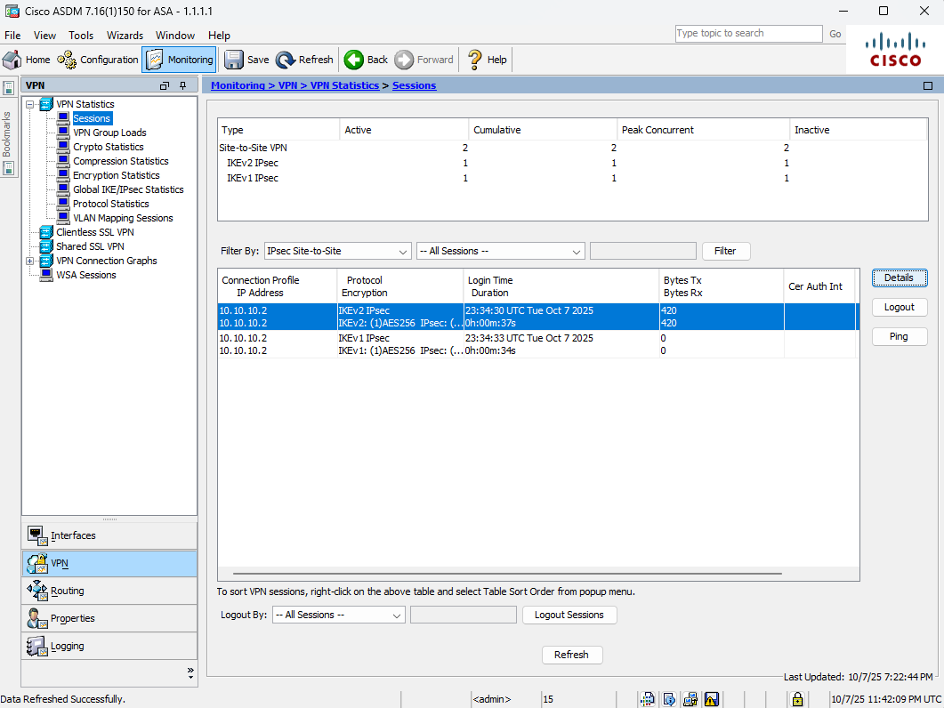
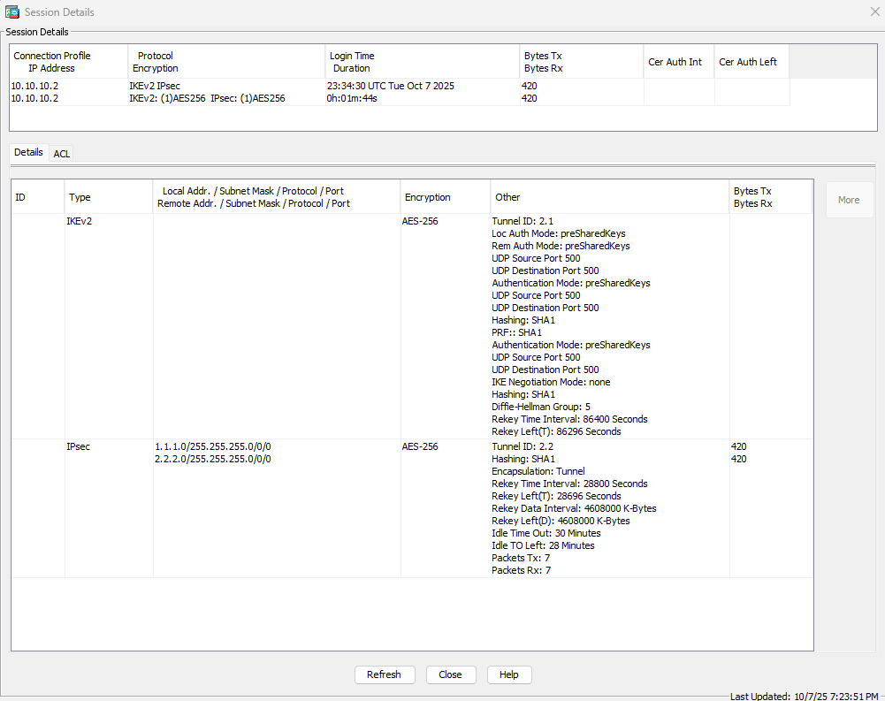
FIREWALL 2
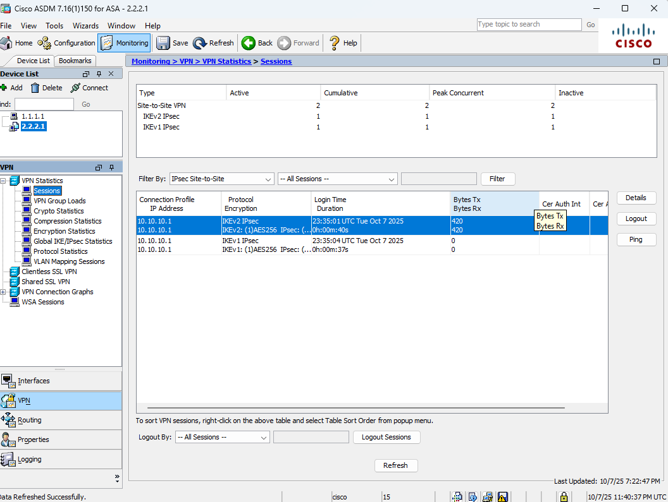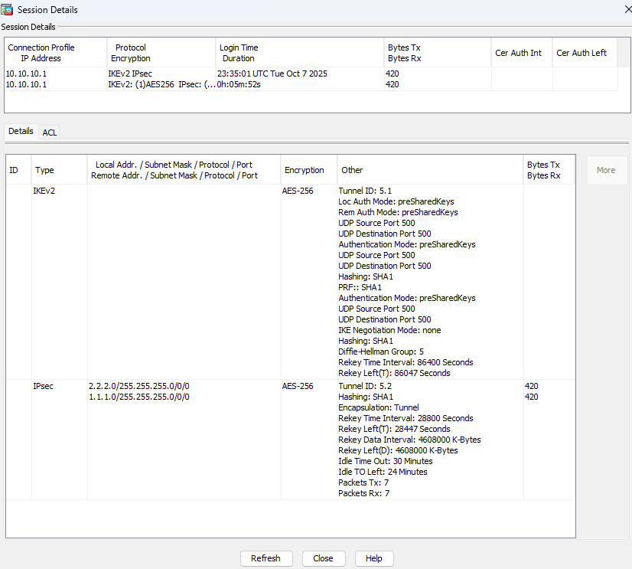

- Draw the lab diagram below (PC’s, router and switch connections) Label the IP addresses, subnet masks, and gateways used by each device. Label the routing tables next to the switch, and firewalls.
